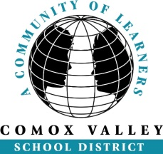
Elementary Try a Trade
The Careers department is helping upper intermediate students learn about the trades as a career option by hosting all grade 7 students to Sandwick Technical School for a day of “hands on” activities. The idea is to put tools and materials into these youth hands, so they can experience what trades are all about. We use senior student leaders, grade 11 and 12, to teach and show the grade 7 students some of the following trades:
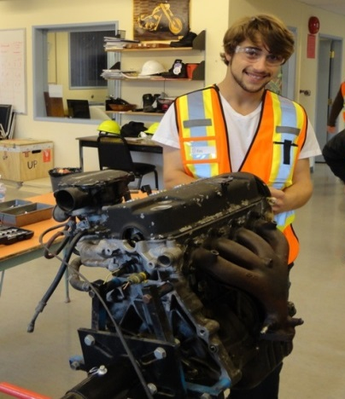
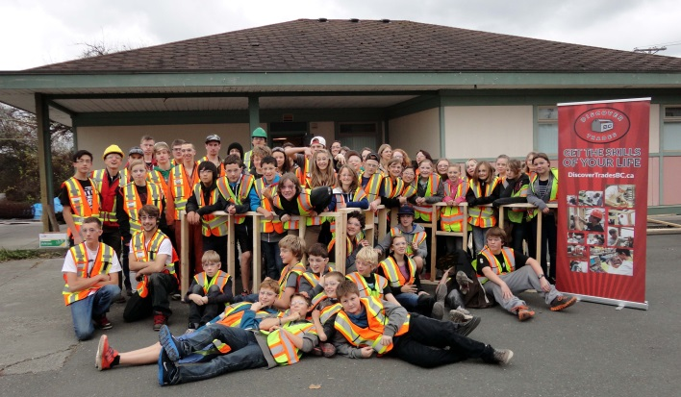
- Carpentry
- Plumbing
- Electrical
- Drywall
- Painting
- Concrete
- Mechanics
- Cooking
- Work safe practices
The day starts out with the senior leaders arriving at 9am, learning and practicing the station, they are going to work at, and then greet the grade 7 students at 11. After a quick introduction and safety lesson, the students rotate through the different trade’s stations, with the emphasis on getting tools in the hands of the students.
To view what goes on, please look at the video showing the action:
Follow the link to “Elementary Try a Trade”
http://www3.sd71.bc.ca/Programs/careerprograms/try-a-trade/Pages/default.aspx on the SD71 Careers web site.
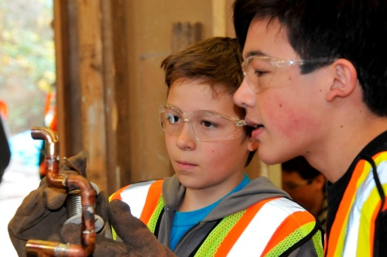
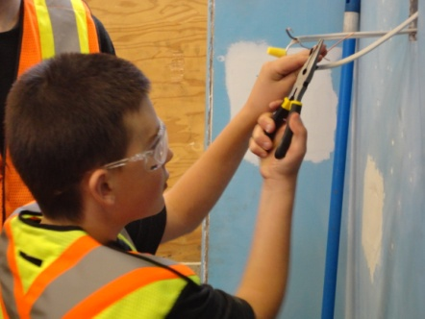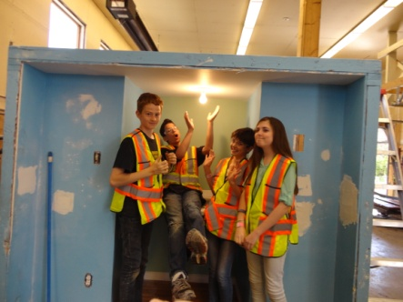

Parents are the #1 source for career counselling of their children. Parents are invited to attend the Try-A-Trade day with their child. Below are some very good web sites to learn more:
ITABC.ca Workbc.ca Careertrekbc.ca
Sincerely
If you do not want your son or daughter in pictures or video, that may be used to promote this event, please send a note to their teacher.
Randy Grey
Randy.grey@sd71.bc.ca

